**CRUD application execution flow**

Step 1 :

1. Clone the repo

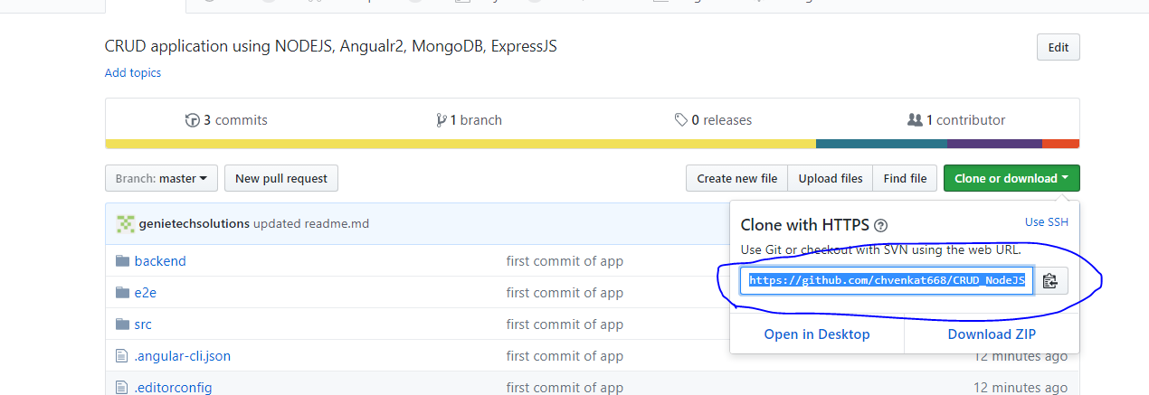

1. Install node_modules for angular@cli

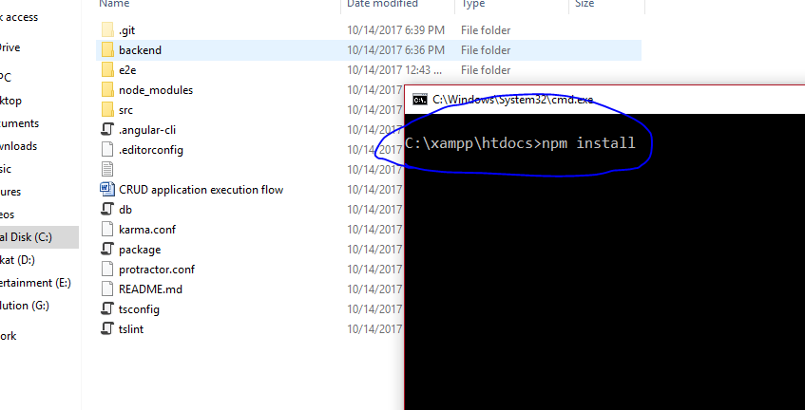

1. Install node_modules for backend and start node server

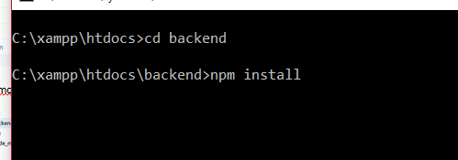

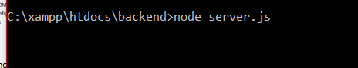

1. Start angular@cli server

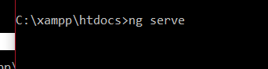

**Your application is ready.**

**#DUMB database**

1. Open Studio3T
2. Press Import



1. Import selected Dumb db from src/db_bkp/ngStore

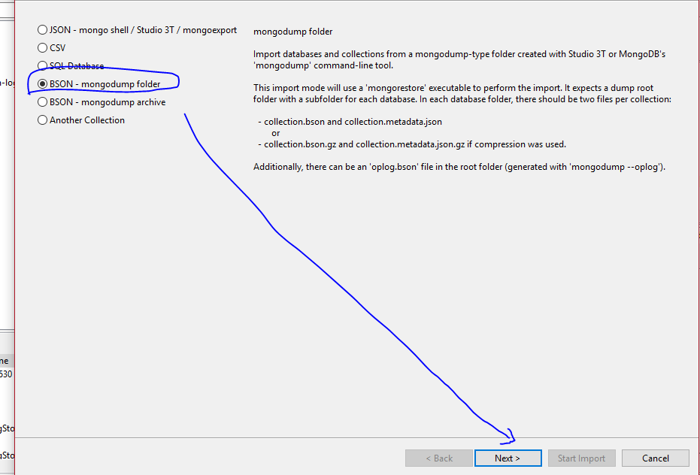

1. Give db dumb file path

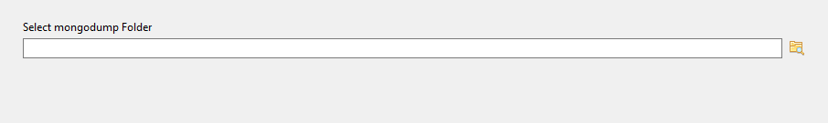

Once done the all steps. Try to login with user gopi/Venkat, if you username is valid you will re-direct to home page other wise, you will be in same login page.